Collateral Web

TFS 92354 – CW 42: Purchased participations secured by chattel

Feature Overview

Request from FCE: LT loans that are purchased participations need to be able to be secured by chattel, rather than having it excluded in calculations on the Collateral Analysis screen. Chattel collateral can be security for LT purchased participations so they need to be treated differently. The rationale is that participation loans are not really LT loans, but are flagged as LT loans for tax purposes.

# Document Change History

|  |  |  |  |  |
| --- | --- | --- | --- | --- |
| Version | Date Changed | Description | Approved By | Date Approved |
| 1 | 08/10/16 | Document started | Rebeca McFarland | 08/10/16 |
|  |  |  |  |  |
|  |  |  |  |  |
|  |  |  |  |  |
|  |  |  |  |  |

Credit Products

August 10, 2016

Table of Contents

Collateral Web 1

Document Change History 1

Statement of the Problem 2

Option A (FPI Recommendation): Allow Chattel to Secure Participation Loan 2

TFS 92354 – CW 42: Purchased participations secured by chattel

## Statement of the Problem

Currently, if you have a participation loan secured by chattel, the MV and NRV of the chattel are not reflected in the Collateral Analysis screen:

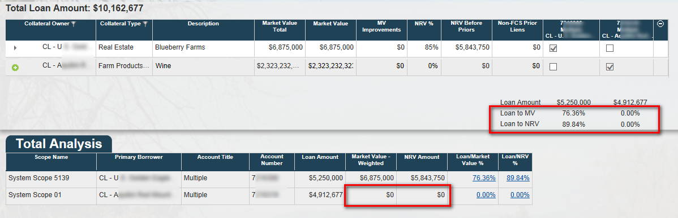

## Option A (FPI Recommendation): Allow Chattel to Secure Participation Loan

The system should perform a behind-the-scenes check on LT loans. If they are participation loans, rather than regular LT loans, than chattel should be allowed as a valid collateral type for securing the loan.